**MyCoeliac**

User Interaction

Research Document

Erasmus+ Glutenproject

13 January 2020

My Linh Nguyen

500774107

Table of Contents

1 Introduction 3

2 Target Audience 4

2.1 Empathy Map 4

2.2 Previous App Test 5

3 The Product Design 8

3.1 Color Palette 8

3.2 User Interface 10

4 Usability Test 12

4.1 Test Plan 12

4.2 Test Results 12

5 Improvements 16

# 1 Introduction

In this research document you can find an overview of the process of designing the interface for MyCoeliac.

MyCoeliac is a product that was developed as part of the Erasmus+ Glutenproject. This project is focused on teenagers between the ages of 12 to 17, who suffer from Coeliac disease. This means that they have a gluten allergy and have to maintain a gluten-free diet in order to be healthy and avoid negative mental or physical symptoms like mood swings, stomach aches, skin problems and many more.

Teenagers are the group who has the most difficulties in sustaining a gluten-free diet. This has a lot to do with feeling isolated from friends and family because of their restrictive diet.

MyCoeliac is an initiative to encourage teenagers to be self-sufficient in managing their diet and spread awareness about their condition with their newfound knowledge.

# 2 Target Audience

The target audience of this project consists of teenagers between the ages of 12 to 17 who got diagnosed with Coeliac disease. Having this condition means that an individual has a gluten allergy.

The difficulty in reaching the goal of this project is that there is no clear solution to the problem.

The first step is to find out what the needs of the users are based on . There are two ways in which we did this: with an Empathy Map and a test on the previous apps conducted by the health students from IT Carlow.

## 2.1 Empathy Map

The first tool that we used is the Empathy Map. The Empathy Map is a model that considers the perspective of the user as the center. Then it considers all senses of an individual: what you hear, what you think (feel), what you see and what you say and do. You first start by thinking of a specific scenario that your user could find themselves in.

In our case an example would have been: eating lunch. Then you try to imagine how or in what way the user would react in that scenario. You write that down for each sense. This way you are empathizing with your user. The bottom section of the map is where you imagine what the user would consider the negative and the positive outcomes of their condition, having Coeliac disease.



*The Empathy Map template*

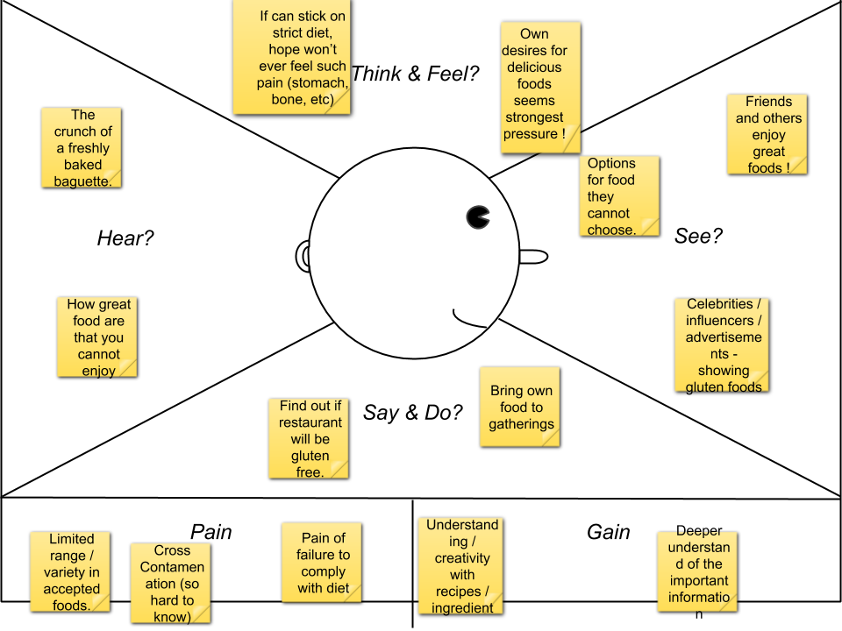

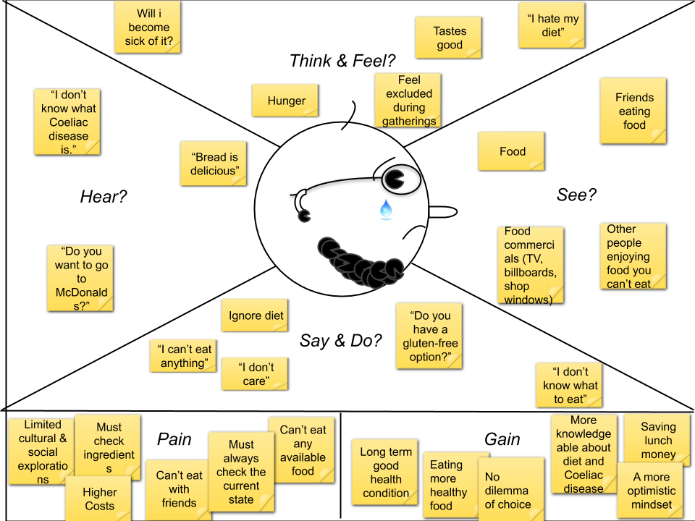

## 2.2 Previous App Test

We did not start this project on a blank canvas. This project has been in development for some time and so far two prototypes of mobile applications has been developed. So, this meant that we had prototypes that we could test to see whether users are receptive towards the solutions.

The first prototype is a mobile application called CeliApp. The CeliApp is a food diary in which users can log the food that they have eaten and they also report their feelings. The goal of the app is to help users find the food that causes them unpleasant symptoms in order to avoid those types of food.

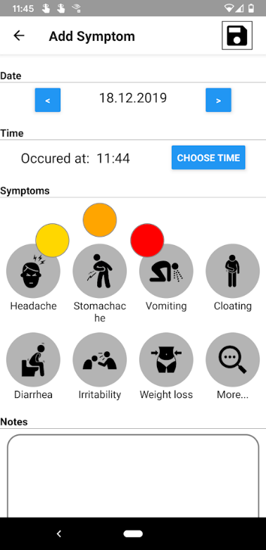*CeliApp*

The second prototype is also a mobile application called Snackfinder. Snackfinder has three main functionalities: food diary, barcode scanner and a restaurant locator.

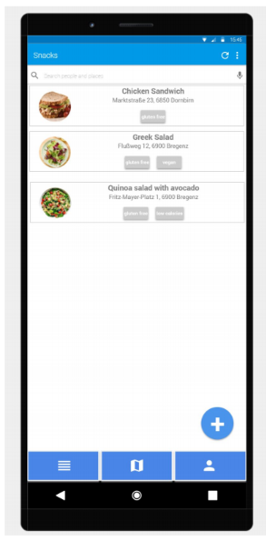*Snackfinder*

Below you can see the results of the test.

So, from the results it can be concluded that users like to have something that is easy and quick to use. They appreciate the functionality of a restaurant finder/map that also allows them to rate and review the restaurants.

The drawbacks concluded from the test results is that users did not like the symptom tracker of the CeliApp. They also found the apps to be lacking a community feature, so some way to interact with others, and a barcode scanner to scan for food products.

These test results were a tremendous help in deciding on what the user like and does not like to use and have in a similar mobile app.

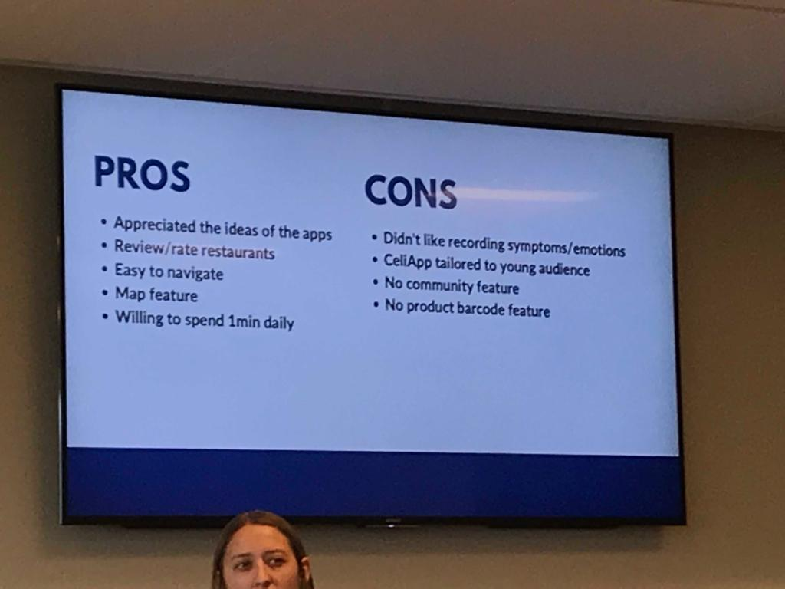

# 3 The Product Design

When it finally came to designing the user interface we really took into account the feedback that was made about the design aspect of previous apps CeliApp and Snackfinder. The stakeholders emphasized that it was important for us that the design of our app is catered to teenagers. It is important to know what they like and what they are interested in.

The way in which we approached this task was to look for the most popular mobile apps used by teenagers and figure out the common design choices of these apps that are user-friendly and intuitively felt by teenagers who use them. Specifically when it came to colors, we researched colors connected to food and what they represent in the general sense.

## 3.1 Color Palette

In the process of creating a color palette or theme colors for our product we researched color meanings in correlation with food. We found an interesting article that touches upon this subject. This article indicates that colors can take on an entirely different meaning and stir up different emotions when it comes to food. The article lists a wide range of colors and tones, and describes the effect of the color on consumers when used in food-related content.

We also thought about the expectations when the realm of gluten comes to mind. The only visual components that comes to mind are food products that contains gluten, which consists mostly of grain foods like bread, pasta and rice. There is not a particular color or group of colors that represents gluten.

<https://jenndavid.com/colors-that-influence-food-sales/>

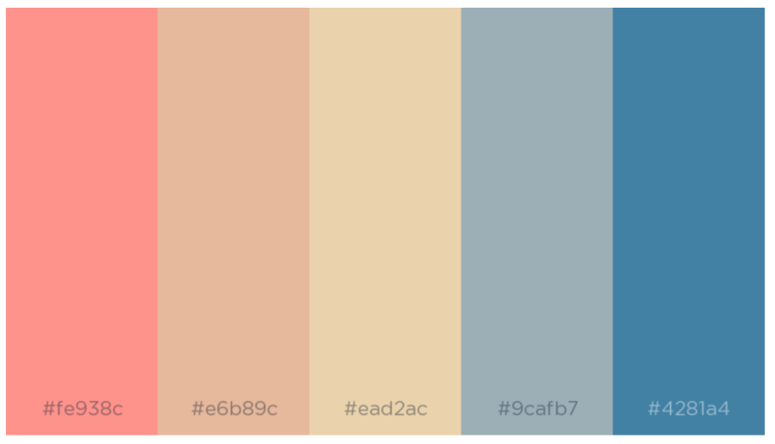

*Theme colors*

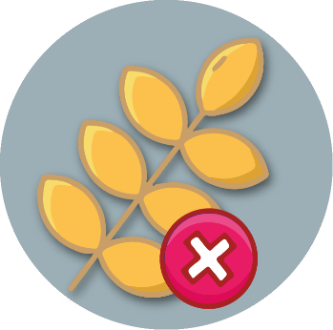

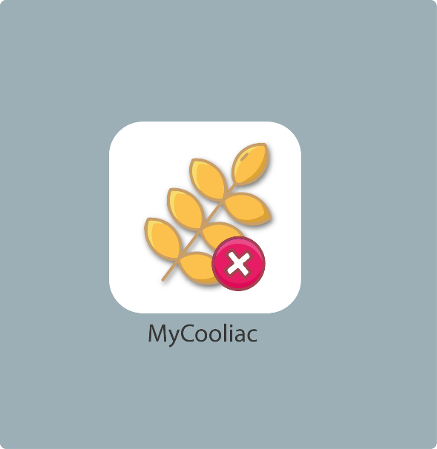

*Logo examples*

## 3.2 User Interface

This is some of the screen designs in the first version of our prototype.

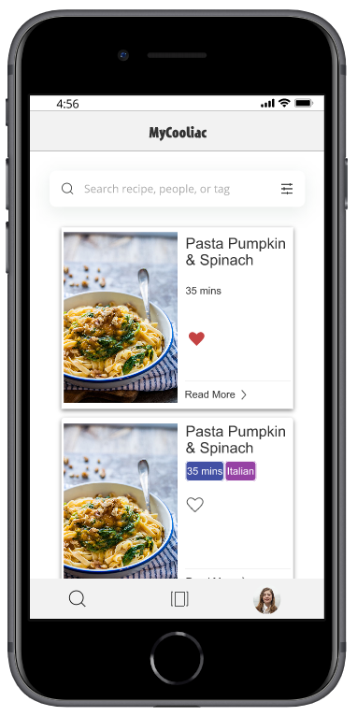*Home screen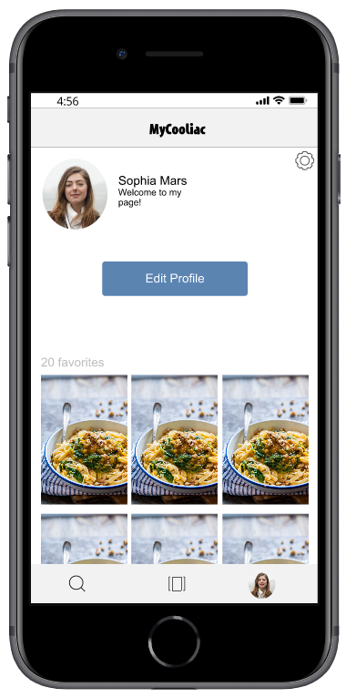Profile screen*

*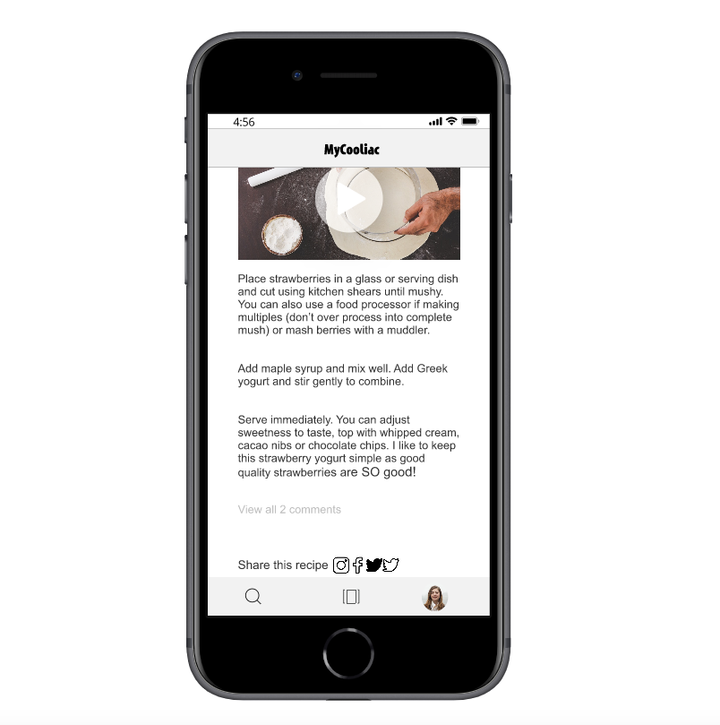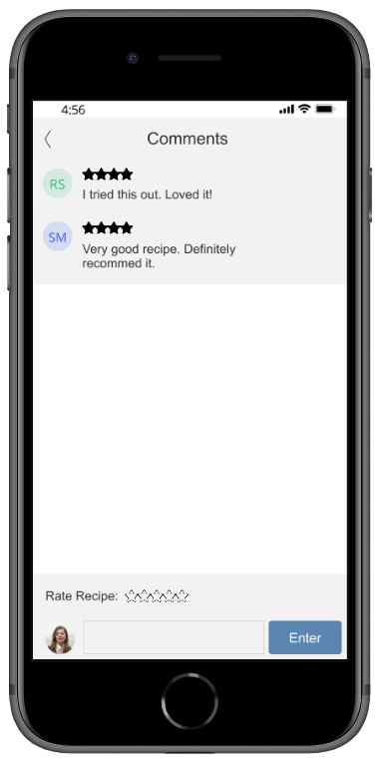Recipe detail screen*

The popular apps that we looked at were Facebook, Instagram, Pinterest and MyFitnessPal. These apps can be sorted into two categories: Facebook and Instagram are one of the most popular mobile apps in general. Pinterest and MyFitnessPal are the more popular apps that are similar in functionalities and context as our product.

We found that a minimalistic design was common in these apps. This means that the interface is very straight-forward and minimal when it came to usage of colors.

# 4 Usability Test

At the end of our international week we got the chance to conduct an usability test. An usability test is used to test whether a product is designed in a way that the usage of it is easy and intuitively.

## 4.1 Test Plan

We looked for components in the design of the product that might be problematic when it comes to the user interaction aspect of the product. Once we decided on the components that we wanted to test, we then made screenshots of the screens that were going to be tested and uploaded them to Tobii.

Tobii is an eye tracking hardware and software. Part of it is the webcam on top of the computer that tracks the eye movement of the user.

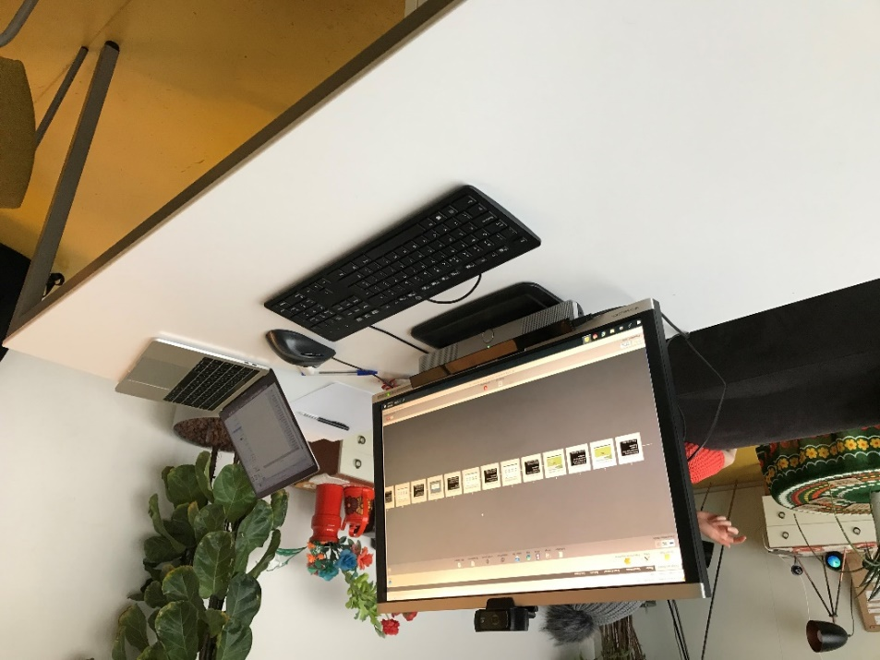

## 4.2 Test Results

Below are the test results of the usability test for each specific scenario.

**Scenario:** Submit rating

**Result:** 33% did not click on Enter

This scenario is about posting a rating for a certain Recipe without any comment. We wanted to see whether users understand what the Enter button is for. The result showed that quite some struggled to understand that the Enter button was there to post an entire review.

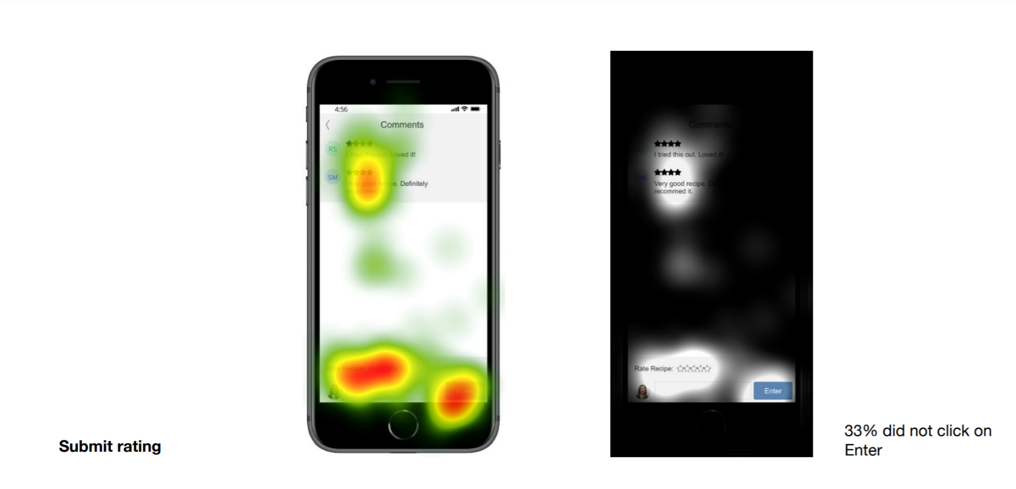

**Scenario:** Add a 4-star rating

**Result:** No problems selecting rating

In the second scenario the user has to be able to rate a recipe. The goal of the task is for them to be able to click on the star rating bar above the text input field. The result shows that users were able to find this bar. Every single user clicked on the star rating bar.

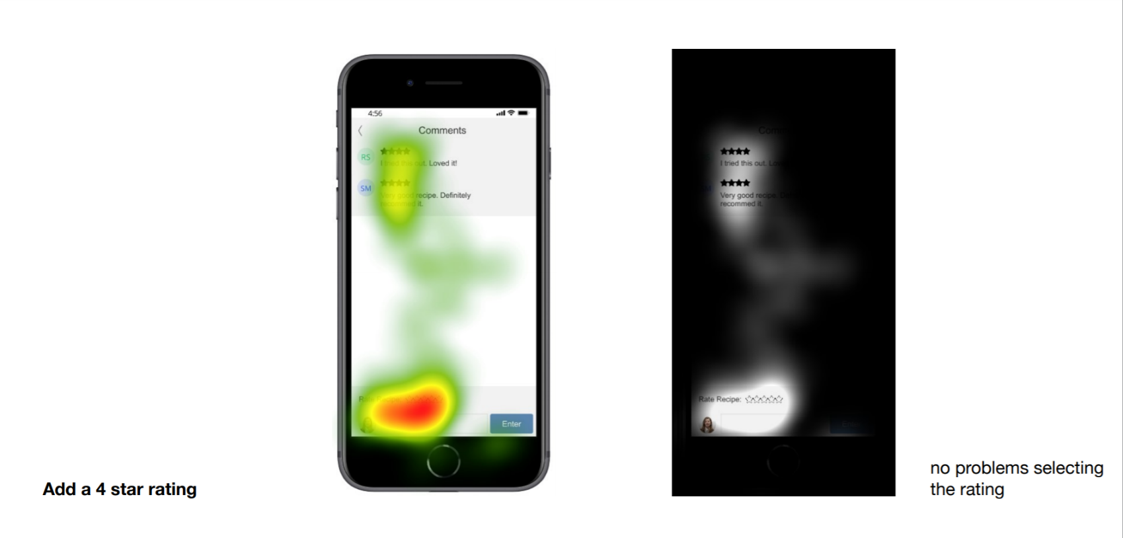

**Scenario:** Add a review

**Result:** 57% did not click on the View comments link

In the first scenario the user is on a specific Recipe detail page and wants to leave a review. The task in this goal is for them to find the button that brings them to a different page where they can leave a review for the Recipe. The result shows that about half of the users were not able to seek this button.

The conclusion is that the title of the button does not clearly indicate for it to allow users the action of reviewing the Recipe. We might be able to solve this problem by altering the title and/or the color of the button, so that the action as well as the existence of the button is clear.

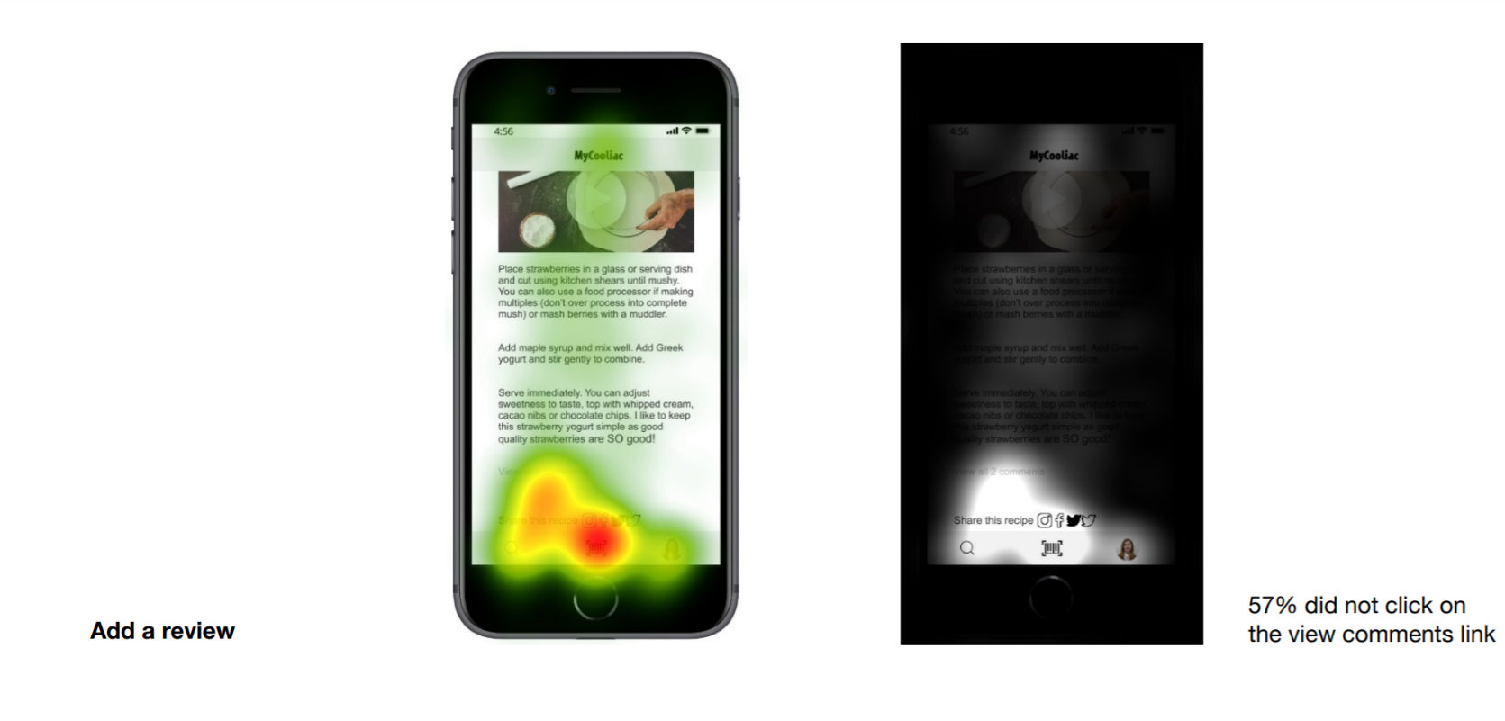

**Scenario:** Log out

**Result:** No one had problems logging out

In this last scenario we wanted to test whether users are able to find the place where the log out button is located. Putting the button to log out in the settings environment of a mobile application has become more common. The test result shows that this design choice has become an intuitive [] for users.

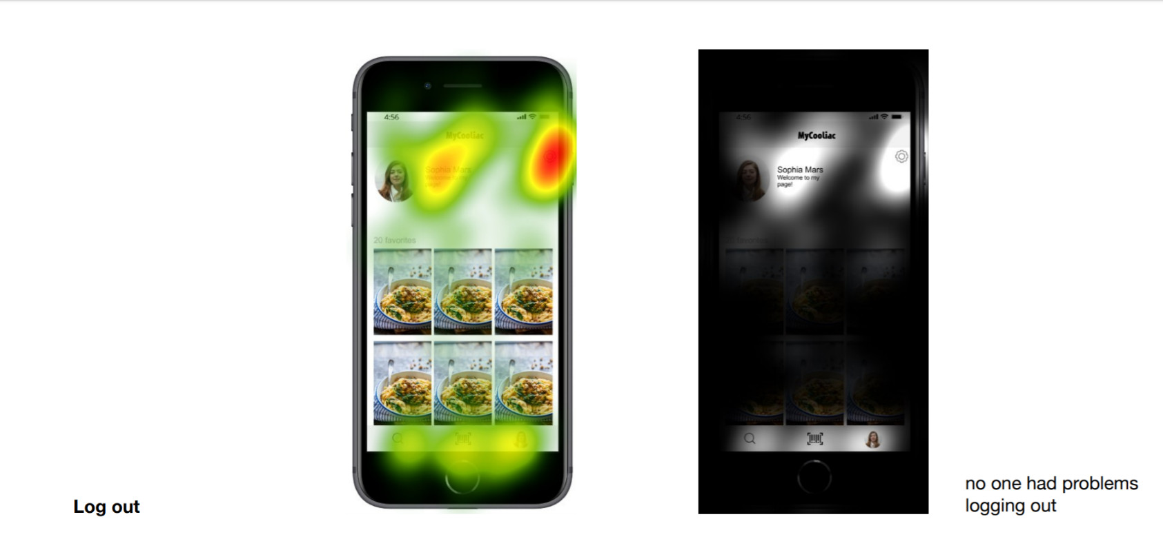

# 5 Improvements

During the second international week we were visited by UX design students from Austria. We got the chance to present them a demo of our product and discuss the improvements that we could make when it comes to our user interface.

The initial feedback of the designers: <https://drive.google.com/open?id=1DotRxRkYee5TR1WT6jQpr5rvMwdICqAy>

Below is an overview of the adjustments made based on the feedback of the UX design students.

The first adjustment was made to the login screen. The feedback was to somehow promote our brand more in order to make the product feel unique rather than a mimic of other apps. So, just by adding our logo to the front of the screen made it that much more unique.

Before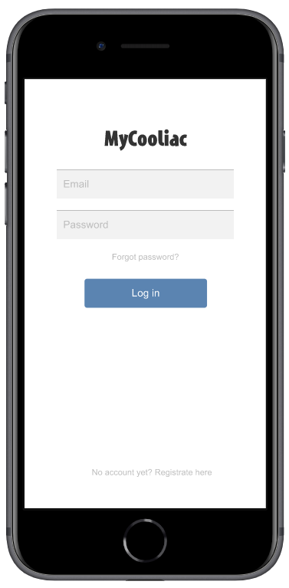After 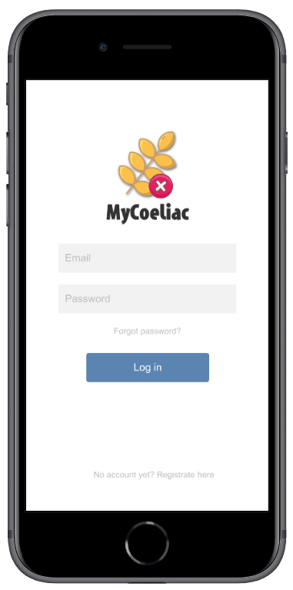

On the home screen is a list of recipes displayed. They wanted us to adjust the layout of the recipe cards. This would boost the main attraction of the card which is the photo of the dish or meal and it solves the problem of redundant white space.

BeforeAfter 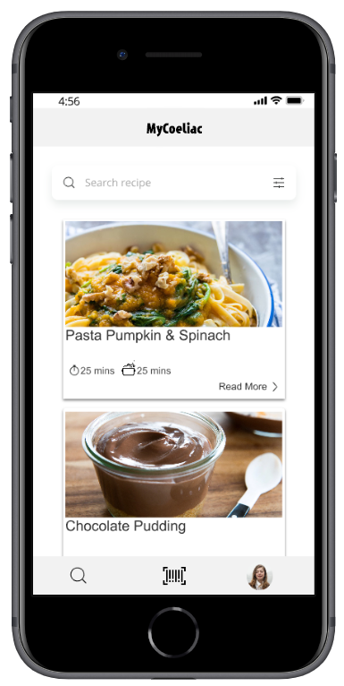

On the profile page they noticed two buttons of which the functionality could be merged. In order to avoid using unnecessary space we merged the edit profile function into the settings button. Editing a profile could also be considered a setting.

BeforeAfter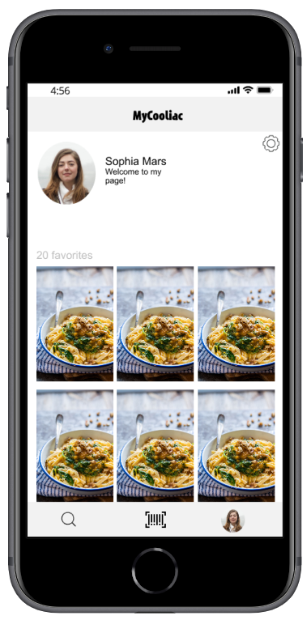

The overall feedback that we got from the design students was that they were positive about our design. They appreciated the minimalistic approach and they liked the fact that we based our design off of popular apps. Using the app gives a sense of familiarity because of that fact, which contributes to the easy-to-use feel.

The design students were great in helping us improve the usability aspect of our design. They made us see the little changes that we could make that contributed to a big change in the use of the user interface.